**PRACTICAL-2**

**AIM:**

**a.** Write a program to calculate the square root of a number by Newton's Method.

**Source Code:**

number = float(input("Enter a number: "))

guess = number / 2 # Initial guess

while True:

new_guess = (guess + number / guess) / 2

if abs(new_guess - guess) < 1e-6: # Tolerance for convergence

break

guess = new_guess

print(f"The square root of {number} is approximately {new_guess:.6f}")

**Output:**

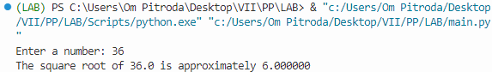

**b.** Write a program for checking whether the given number is an even number or not.

**Source Code:**

number = int(input("Enter a number: "))

if number % 2 == 0:

print(f"{number} is an even number.")

else:

print(f"{number} is not an even number.")

**Output:**

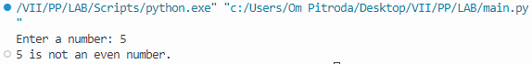

**c.** Write a program using a while loop that asks the user for a number, and prints a countdown from that number to zero.

**Source Code:**

number = int(input("Enter a number: "))

while number >= 0:

print(number)

number -= 1

**Output:**

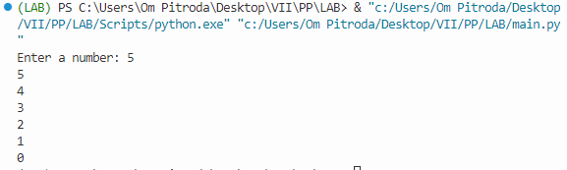

**d.** Write a program that uses for loop to print all the odd numbers in the range input by user

**Source Code:**

e start = int(input("Enter the start of the range: "))

end = int(input("Enter the end of the range: "))

print("Odd numbers in the range:")

for num in range(start, end + 1):

if num % 2 != 0:

print(num)

**Output:**

